April is the month of

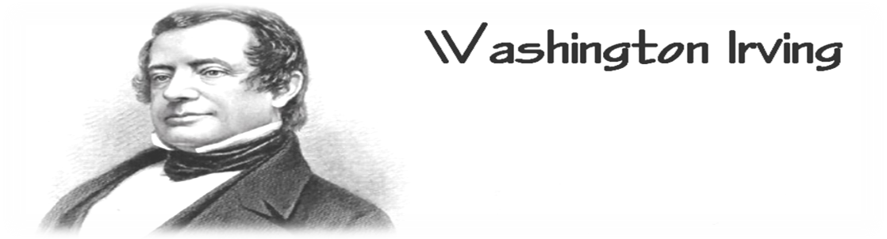
Washington Irving was an American writer.
He was born on 30th April 1783, in New York.
As a young man he studied law and later
worked in several law companies. From 1802, he wrote short stories and essays. At first, these were only published in newspapers, but later they were collected together and published in books.
Irving was the first American writer of humorous stories. He also wrote a book about the first American president George Washington. Irving`s two best known stories The Legend of Sleepy Hollow and The Legend of Rip Van Winkle were published in 1820, in The Sketch Book.

“Great minds have purposes, others have wishes.“
The story of a farmer named Rip Van Vinkle takes you to the Catskill Mountains, in North America. Rip Van Vinkle is a lazy man who loves telling stories and doing nothing. That is why his farm is falling apart and his wife keeps yelling at him. One day Rip Van Vinkle takes his rifle and goes hunting. In the Catskill Mountains he meets a strange old man carrying a large wooden barrel on his shoulders. Rip Van Vinkle follows him and shares a drink with the old man and his friends. And then he falls asleeep....When he wakes up, things are different.
“There was another strange thing about the old men. Again and again, they rolled the balls in their game of nine-pins. But they never spoke to each other. The only noise that Rip could hear was the sound of the heavy balls. Suddenly, Rip was very frightened!“
The Legend of Sleepy Hollow is a fantasy as well as romantic story. Beautiful and rich Katrina wins admiration of all the young men in the area where she lives. When suddenly one of them, Ichabod Crane, disappears, there are rumours of Headless Soldier taking him to the Underworld...

