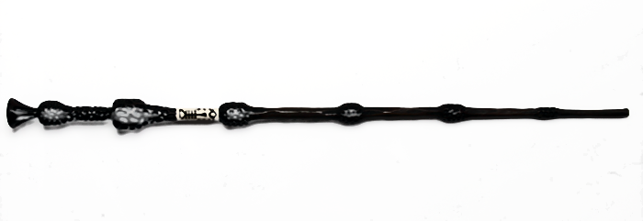
Expelliarmus!

Having read Harry Potter (for the first time in my life, and in English) I must admit two things:
- J.K.Rowling is way better writer than I`ve ever thought
- seeing the H.P. films first really helps
Harry Potter and Deathly Hallows became a true challenge. Many times before I had asked my students to read H.P in English, now I know how much I wanted from them. I`m really sorry. It`s hard and I wanted to give up every single day.
The two final H.P films were great, the scriptwriters did an excellent job. However, the book`s extraordinary.
What we can`t see in the films is what Dumbledore`s life was like. We knew him as the best wizard of his era, perfect teacher and headmaster. The truth is, his beginnings weren`t always so bright. Gellert Grindelwald, a master of Dark Arts, dreamed of ruling the word. And Albus Dumbledore shared his dreams.
“You cannot imagine how his ideas caught me, Harry, inflamed me. Muggles forced to subservience. We wizards triumphant. Grindelwald and I, the glorious young leaders of the revolution.“ (H.P. and the Deathly Hallows, Bloomsbury, 2014, p.585)
Later, their friendship broke up. We learn that there was a duel between them in 1945.
“I think he knew it, I think he knew what frightened me and I delayed meeting him until, finally, it would have been shameful to resist any longer. People were dying and he seemed unstoppable, and I had to do what I could. And you know what happened next. I won the duel. I won the wand.“ (H.P. and the Deathly Hallows, Bloomsbury, 2014, p.587)
Well, to understand the Dumbledore-Grindewald relationship you must read the book!
Another surprising moment came when J.K.R changed the way I had seen Severus Snape. He, with his black greasy hair, pale skin and long black cloak, can`t be a likeable character, can he?
And yet, the Dark Prince is not do dark. His deep love for Harry`s mom defines his acts (even those criminal ones). At the end of the book, you must forgive him. There`s no other way.
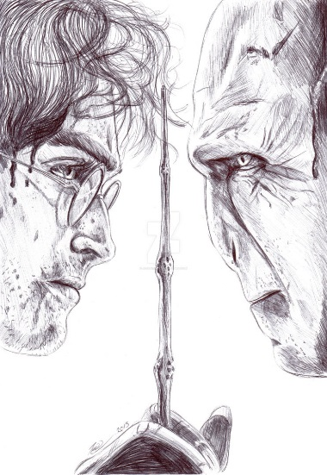
“Severus Snape wasn`t yours, said Harry. Snape was Dumbledore`s, Dumbledore`s from the moment you started hunting down my mother. And you never realised it, because of the thing you can`t understand.”
“Is it love again?” said Voldemort, his snake`s face jeering, “Dumbledore`s favourite solution, love…” (H.P. and the Deathly Hallows, Bloomsbury, 2014, p.604-605)
And then, the epic ending came. Who was the true master of the Elder Wand?
“Avada Kedavra!“
“Expelliarmus!“ Harry saw the Elder Wand fly high, dark against the sunrise, spinning through the air towards the master it would not kill.... And Harry caught the wand in his free hand as Voldemort fell backwards.....

