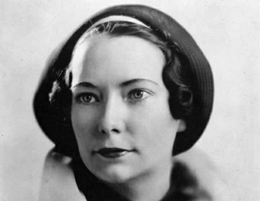
November is the month of Margaret Mitchell

Margaret Mitchell was an American writer, who was born in Atlanta, Georgia, in November 1900. Margaret began making up stories before she could write, dictating them to her mother. Later, she started to make “her own books“ with cardboard covers and filled them with adventures using her friends and family members as the main characters.
In 1926, Margaret started to write GONE WITH THE WIND (ODVIATE VETROM). At that time she was quite bored, because she had broken her ankle and couldn`t walk at all.
First, she wrote the last chapter and then the other chapters randomly. It took her 3 years to write the novel. Gone with the wind is a romantic novel about the Civil War and the terrible years after. It was the war that we know as “The North against the South.“And this terrific novel tells the story of the war from a southern point of view.
It`s not only a romantic novel, it`s also a history textbook and a book of etiquette.
It`s heart-breaking, gripping, fast-moving and ...not predictable at all!!!
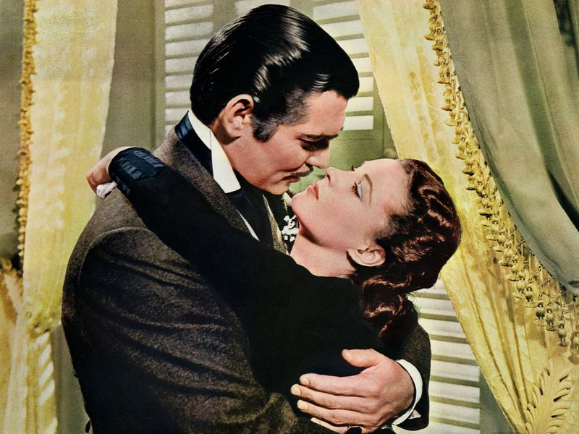
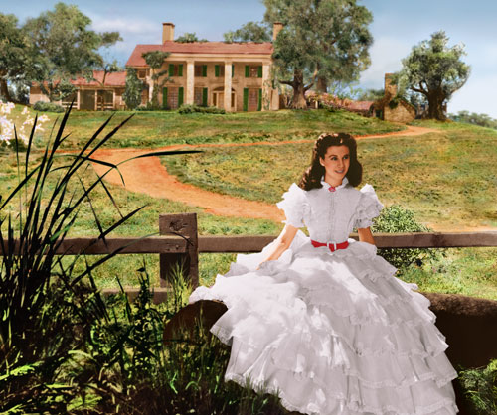
Gone with the wind was published in 1936 and was an immediate success. Margaret Mitchell became an overnight celebrity. Three years later a movie based on her book was released, starring Clark Gable and Vivien Leigh. It won 8 Oscars and 2 special Oscars ☺

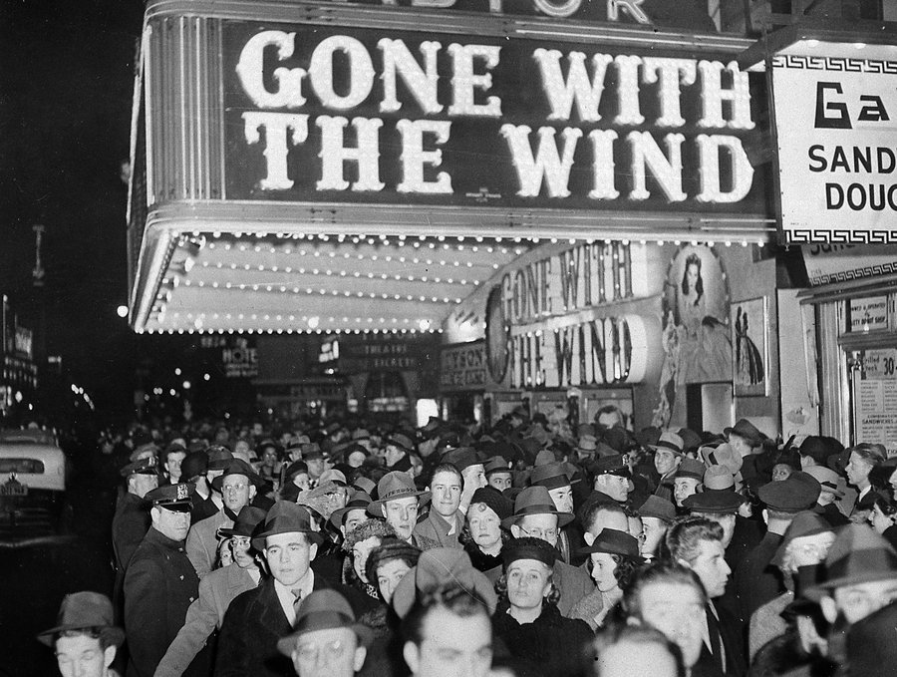
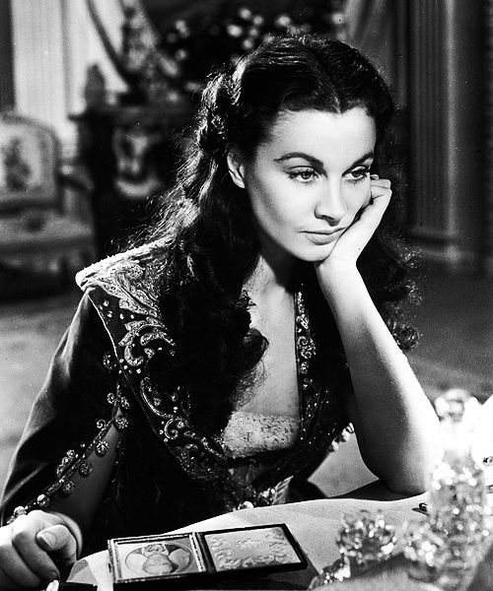

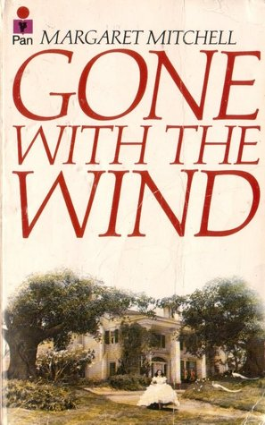
“You, Miss are no lady,“ Rhett Butler said. “But ladies rarely interest me, and I cannot understand, my dear Miss O`Hara, what a wild and hot-blooded girl like you can find to like about the handsome but very boring MrWilkes.“
The story of Gone With theWind begins in April 1861 in the southern part of the United States. Every young man for miles around is in love with sixteen-year-old Scarlett O`Hara. But Scarlett can think of no one but Ashley Wilkes, the handsome, intelligent, perfect Southern gentleman. He is planning to marry Melanie Hamilton, but Scarlett will do anything to spoil the wedding plans.
Although Ashley loves Scarlett, he knows they are wrong for each other. They are just too different. The Wilkes family enjoys reading books, going to Boston and New York to see paintings and hear music. Scarlett, on the other hand, is a wild and hot-blooded girl. Moreover, she`s not very educated.
Rhett, an older man with dark past, likes the fire in Scarlett`s character and is amused by her selfishness. He is nothing like the gentlemanly Ashley Wilkes, but he `s clever, handsome and charming. He understands Scarlett and wants her for himself.
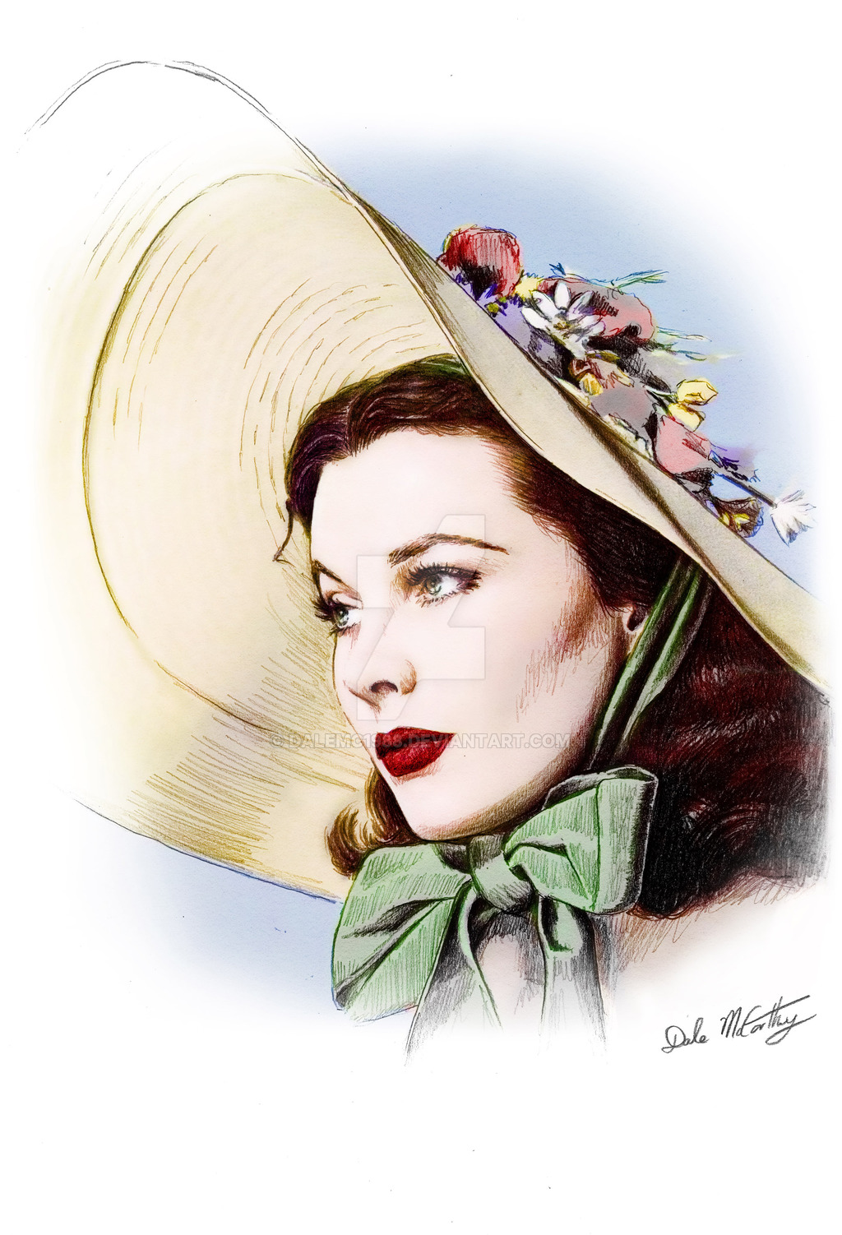
Scarlett is very confident, selfish young woman. She will do anything to get what she wants. But she is completely without feelings for others. And neither is Rhett. In fact, although they fight almost every time they meet, Scarlett and Rhett find that they have more similarities than differences in their characters.
The story of Scarlett O`Hara, Ashley Wilkes and Rhett Butler is one of the greatest love stories ever told. It`s also a story of the American Civil War and the death of the lifestyle of the OLD SOUTH after that terrible war.
Scarlett took two steps forward, but Will stopped her.
“Don`t spoil it,” he said quietly.
“Let me go, you fool! Let me go! It`s Ashley.”
Will held her. “It`s her husband, ain`t he?” he said calmly.
Scarlett looked at him angrily-and in the quiet kindness of his eyes, she
saw understanding and pity.

