The Simpsons and Their Hilarious Language
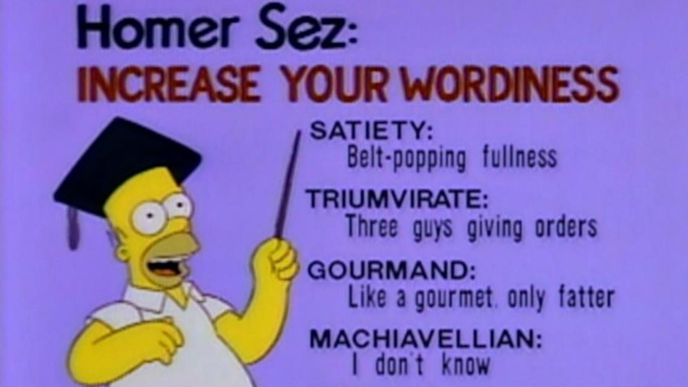
The Simpsons have never been ones to play by the rules, and the same goes for their loose approach to the English language. From mispronunciations to portmanteaus to just plain made-up nonsens. There I introduce to you several favourite coinings from Homer and his company. So let’s take a seat and enjoy your reading about what you really like and learn something, maybe, you have skipped during watching your favourite series.

EMBIGGEN
Springfield founder Jebediah Springfield’s statue in the town square bears his most memorable quote: “A noble spirit embiggens the smallest man.” So inspirational. The pioneer did not have just a figurative silver tongue, though; he had a literal one as well. He got his prosthetic tongue after losing his real one to a Turkish pirate in a grog house fight.
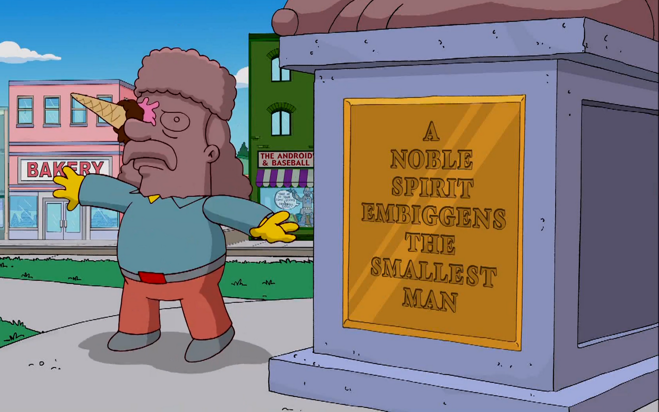
CROMULENT
“Embiggen?” you ask, one eyebrow raised? Lisa Simpson´s 2nd grade teacher Ms. Hoover has your answer: “It is a perfectly cromulent word.” I think that cromulen, as a funner-to-say synonym for acceptable or fine, is a perfectly cromulent candidate for potentially embiggening dictionary at some point.

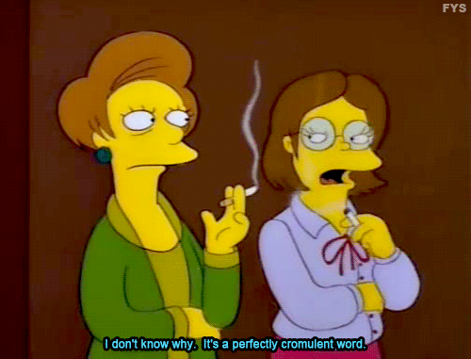
DICKETY
Most of the new words in The Simpsons do not get called out as being new words. One exception is dickety, which Grandpa Simpson, in one of his rambling and dubious stories from his past, says they had to come up with after Kaiser Wilhelm stole the word twenty. “I chased that rascal to get it back,” Grandpa said, “but gave up after dickety-six miles.”
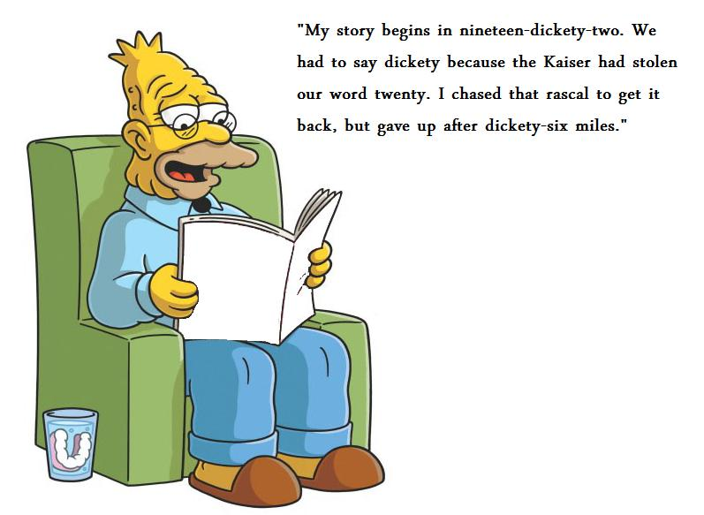
TOMACCO
When Homer takes up farming and accidentally cross-breeds a couple seeds, he calls his new tomato-on-the-outside, tobacco-on-the-inside plant a tomacco. Bart describes the tomacco´s taste as terrible but “smooth and mild, and refreshingly addictive,” while Ralph Wiggums thinks it “tastes like grandma.” Mmmm, tomacco.
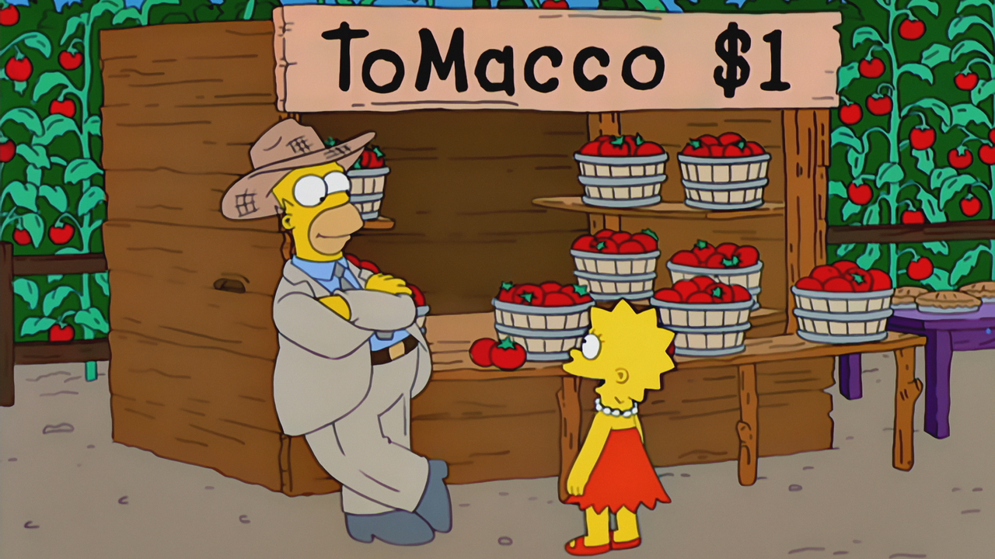

CHOCOTASTIC
The other component (e.g. bonus eruptus – as an imaginary illness of Grandpa Simpson invented by Dr. Nick) to Dr. Nick’s weight gain program “dangerously underweight individuals” like Homer are the neglected food groups: fats and sweets, whipped group, the congealed group, the empty calorie group, and of course, the chocotastic!
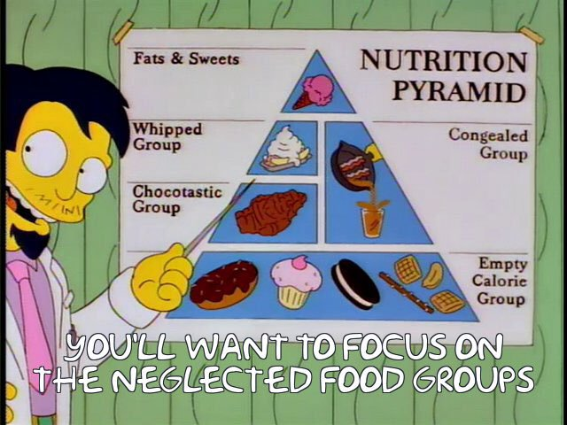

UNPOSSIBLE
To be thr dumbest person in Springfield is quite an achievement, but if anybody deserve the title, it is Ralph Wiggum. The 2nd grader´s stupidity is our gain in that it has given us quotes as „I am learnding,“ and, in response to Lisa´s explanation that „Players play and managers manage,“ “Do alligators alligate?” Perhaps the most famous quote is, “Me fail English? That´s unpossible!” It is unpossible that this one will make it into the dictionary someday?
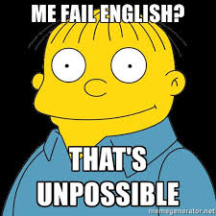

D´OH
This list wouldn’t be complete without Homer’s most famous word – or noise, rather. While d´oh was around before The Simpsons, Homer made it famous enough to get into dictionary. We define it as an interjection “used to express dismay when one has said or done something stupid, or when something has gone wrong.” The TV show writer just calls it Homer’s annoyed grunt. Either way, it is hard to imagine The Simpsons – or life – without it.
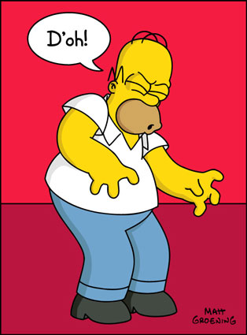

Incorrect pronunciation of a word
A word blending the sounds and combining the meanings of two others, for example motel or brunch.
Enlarge – e.g. You have to enlarge/enrich your vocabulary
Departing from a literal use of words; metaphorical
A tendency to be eloquent and persuasive in speaking.
Acceptable or adequate.
twenty
(of writing or speech) lengthy and confused or inconsequential
Suffering a lack of proper care/Not receiving proper attention; disregarded
CITOSLOVCE

